}

Guía1. Definición Proyecto APT
Asignatura Capstone

- PARTE I
1. Antecedentes Personales
A continuación, se presenta una tabla en la que debes completar la información solicitada.

Nombre estudiante | Héctor Cornejo  Paul Hidalgo  Angel Rengifo  Melanie Ortiz
Rut | 18.866.387-7  21.611.703-4  27.477.068-6  21.243.103-6
Carrera | Ingeniería en Informática
Sede | Plaza Norte

2. Descripción Proyecto APT
En la descripción debes señalar brevemente el nombre de tu proyecto APT y las competencias del perfil de egreso que vas a poner en práctica. Si en tu carrera están definidas las áreas de desempeño, también menciona a qué áreas de desempeño está vinculado el proyecto.

Nombre del proyecto | Siempre Cerca
Área (s) de desempeño(s) | Menciona la(s) área(s) de desempeño de tu Plan de Estudio que vas a abordar en tu Proyecto APT.  The areas of activity our APT project will address are as follows:  - Mobile development.  - System design.  - Project management.  - System architecture.  - System quality and security.  - Databases.
Competencias | Menciona las competencias de tu Plan de Estudio que vas a abordar en tu Proyecto APT.  The competencies we will address in our APT project are as follows:  - Teamwork  - Problem-solving  - Proactivity  - Logical thinking  - Effective communication  - Time management

3. Fundamentación Proyecto APT
A continuación, se presentan distintos campos que debes completar con la información solicitada. Esta sección busca que describas en detalle tu proyecto y justifiques su relevancia y pertinencia.

Relevancia del proyecto APT | Currently, a large percentage of older adults live alone or far from their families. This geographical and daily distance creates a constant burden of worry and stress for their children, who fear that their parents might experience medical emergencies, falls, disorientation, or health complications—such as those related to chronic conditions like diabetes—without anyone being there to provide timely assistance.  Given this reality, we decided to create this application as a technological bridge designed to address the specific needs of both parties.  We chose this focus because caring for and monitoring older adults is often complex and challenging, especially when they live alone or are physically distant from their relatives. The lack of regular communication and the uncertainty that arises from not knowing how they are doing on a day-to-day basis can be distressing. Our project aims to provide greater security and peace of mind, particularly during emergencies.  The project will be implemented in Chile, specifically within the Metropolitan Region and its surrounding municipalities, where many families face difficulties—due to geographical distance, travel time, and work commitments—in maintaining constant oversight of their older relatives. This creates a need for technological tools that can track their location, send alerts, and enable timely action in the event of an emergency. Furthermore, this is not a challenge unique to Chile; it is an issue faced by families all over the world.  The problem primarily affects older adults—especially those who live alone, have limited mobility, suffer from chronic illnesses, or are prone to episodes of disorientation.  It also impacts their family members and close social circle, who live in a state of constant concern, unsure whether their loved ones are safe. Through this application, we aim to facilitate an effective response to potential high-risk situations.  The value proposition of this project lies in developing and delivering a solution that promotes both safety and autonomy through a real-time location tracking system. From a social perspective, the application seeks to alleviate the concerns of families and enable a faster response during critical situations. In a professional context, it represents the practical application of Computer Engineering knowledge to develop digital products aimed at solving real-world problems, incorporating current technologies such as GPS, databases, and various features typical of mobile applications.
Descripción del Proyecto APT | The primary goal of this project is to enhance the safety of older adults in situations where leaving their home might lead to disorientation, memory lapses, or an inability to return on their own. This solution will provide caregivers with a reliable way to locate the individual, while also offering additional features for use in emergencies.  To address this challenge, we plan to develop an application designed for both older adults and their caregivers. The app will include various functions, with a core focus on keeping caregivers informed about the older adult’s whereabouts—such as alerting them if the individual moves beyond a specific area or experiences a fall.
Pertinencia del proyecto con el perfil de egreso | Our APT project aligns with the graduate profile for the Computer Engineering program by requiring the application of several key competencies. These include mobile development—as we are creating an application as our solution—and project management, which involves managing a project from the ground up by leveraging the skills acquired throughout our degree. The project also entails system design, requiring the creation of mockups and prototypes to define the system's layout; a focus on system quality and security, ensuring the platform meets necessary standards—especially given that it will handle sensitive data requiring careful management—which we will verify through various tests; and finally, system architecture, for which we will apply our accumulated expertise to design and implement the system's underlying structure.
Relación con los intereses profesionales | Our team’s professional interests center on creating solutions through software development—specifically, building technological applications capable of generating a positive impact. We are also keen to engage in projects where technology serves a practical purpose and delivers value to users, blending innovation, creativity, and technical expertise.  This project aligns directly with our professional interests, as it incorporates various technologies, such as databases and real-time geolocation. It allows us to apply our skills in programming, project management, and requirements analysis, with a focus on improving the quality of life for older adults.  The project will contribute to our professional growth by helping us strengthen both technical and soft skills, apply the knowledge gained during our academic studies, and acquire hands-on experience in developing a comprehensive software solution. Furthermore, through this project, we are transforming an idea into a technological tool that addresses a real-world challenge, providing innovative solutions through information technology.
Factibilidad de desarrollo del Proyecto APT | It is feasible to carry out our APT project, as we have sufficient time—approximately four months—to manage, develop, and complete it. Furthermore, we have access to all the necessary resources, including development tools, internet connectivity, databases, APIs, and hardware. Certain external factors will facilitate the development process, such as the team members' access to various development tools, documentation, and the internet. Conversely, potential challenges include connectivity issues, difficulties in synchronizing different tools, or the risk that the project may not prove useful to our target audience. To address these potential issues, we will conduct surveys prior to development to gather input from prospective users, and we will carry out the necessary research and documentation to prevent compatibility problems.

- PARTE II
4. Objetivos
En este apartado debes definir objetivos generales y específicos del Proyecto APT. Es importante aclarar que los objetivos se deben plantear en forma clara, concisa y sin dar mayores explicaciones, es decir, deben entenderse por sí solos. Se sugiere redactarlos utilizando un verbo en infinitivo, pues ello obliga a precisar acciones concretas.

Objetivo general | The overall objective is to develop a mobile application focused on the monitoring and safety of older adults, enabling their family members or caregivers to access precise, real-time location information, as well as reports on emergencies or incidents—such as falls or episodes of disorientation—with the aim of minimizing risks through rapid, timely responses and reducing concern.
Objetivos específicos | Intuitive design with robust security.  Cloud database integration.  "Ring the phone" feature to help locate it.  Emergency button.  Cloud database integration for the secure storage and management of application data.  Real-time GPS tracking.  Automatic alerts sent to family members.  Alerts sent to your mobile device if the user leaves a predefined "safe zone."  Display medical information on the lock screen (name, medical conditions, allergies, emergency contact).  One-touch "guide me home" feature.  Reminders for daily activities (blood glucose monitoring, meals, insulin).  Medication reminders.  Detection of unusual behavior (e.g., if the user has not left their room for many hours, or has walked an excessive distance).

5. Metodología
En el siguiente apartado deberás describir la metodología, propia de tu disciplina, que utilizarás para resolver el proyecto APT antes descrito, incluyendo las etapas y métodos de trabajo.

Descripción de la Metodología
The project will be developed using the Scrum agile methodology, which organizes work into short cycles known as "Sprints." In each Sprint, the features to be developed will be defined, implemented, and subsequently evaluated based on user feedback.
The project will encompass stages including requirements analysis, design, architecture development, front-end and back-end implementation, integrations, testing, and application validation. Additionally, regular meetings will be held to review progress, identify challenges, and adjust tasks according to the project's evolving needs.
Each team member will be assigned tasks to be completed within the required timeframe. This methodology will enable continuous monitoring and growth of the project, prioritizing the most important features and allowing for progressive improvements.

6. Evidencias
A continuación, describe qué evidencias serán evaluadas en el informe de avance y en el informe final de tu proyecto APT. Estas evidencias deben ser acordadas con tu docente.
Se entenderá por evidencia los productos que se desarrollen durante el proyecto y cuyo propósito sea visibilizar o documentar cómo se ha implementado el trabajo.

Tipo de evidencia  (avance o final) | Nombre de la evidencia | Descripción | Justificación
Phase 1 Progress | Problem Analysis and Problem Statement Document | Document presenting the identified problem, its context, causes, consequences, and initial proposed solution. | Demonstrates that the solution is based on a previously analyzed and substantiated problem.
Phase 1 Progress | Project Evaluation Document | Document that analyzes the initial viability and feasibility of the project from different perspectives. | Determines whether the proposed solution can be developed considering the available resources and conditions.
Phase 1 Progress | Project Charter | Document that formally establishes the project's objectives, scope, stakeholders, risks, and general aspects. | Formally establishes the project's foundations and guides its development.
Phase 1 Progress | Stakeholder Register | Register of the main individuals and organizations involved in the project and their interests. | Identifies the people and organizations that may influence or be affected by the solution.
Phase 1 Progress | Gantt Chart | Project timeline showing the main activities throughout the development phases. | Organizes activities and monitors compliance with established deadlines.
Phase 1 Progress | Mind Map | Visual representation of the problem, its challenges, impacts, and proposed solution. | Provides a structured understanding of the problem's causes and consequences and their relationship to the solution.
Phase 1 Progress | Stakeholder Map | Representation of the users, internal and external stakeholders, and organizations related to Siempre Cerca. | Visualizes the ecosystem of stakeholders involved in or connected to the solution.
Phase 1 Progress | Product Definition | Document establishing the Product Goal, vision, pillars, scope, and expected impacts. | Clearly establishes what Siempre Cerca aims to achieve and the initial boundaries of the project.
Phase 2 Progress | Requirements List | Document compiling the functional and non-functional requirements of the solution. | Transforms identified needs into specific conditions that the system must meet.
Phase 2 Progress | User Stories | Stories describing functionalities from the users' perspective. | Represents users' needs and guides the development of functionalities.
Phase 2 Progress | Architecture | Design of the technological components and their relationships within the solution. | Defines the technical structure required to implement the system.
Phase 2 Progress | Database | Database model and information storage structure for the system. | Organizes and manages the information used by the application effectively.
Phase 2 Progress | Mockup | Visual prototypes of the application's interfaces. | Allows the navigation, design, and usability of the solution to be validated in advance.
Phase 2 Progress | Agile Management Documents | Documentation related to the Product Backlog, Sprints, and development progress tracking. | Demonstrates the application of the Scrum methodology throughout the project.
Final | Testing Plan | Document defining the testing strategy, scope, and test cases for the solution. | Verifies that the system operates according to the established requirements.
Final | Bug Log | Record of identified bugs, corrections made, and the status of incidents. | Provides evidence of the application's improvement process and quality control.
Final | Economic Evaluation | Estimation of the costs associated with the development and implementation of the solution. | Assesses economic feasibility and the resources required for real-world implementation.
Final | Installation Manual | Document containing the steps required to install, configure, and run the solution. | Facilitates the implementation and operation of the system.
Final | User Manual | Document explaining how to use the main functionalities according to each user role. | Helps users operate the application correctly.
Final | Continuity and Maintenance Plan | Document establishing actions to keep the solution operational and support its evolution. | Plans the maintenance, updating, and continuity of the system.
Final | Completed App | Functional version of the Siempre Cerca mobile application. | Represents the main technological product developed throughout the project.
Final | Final Report | Document consolidating the project's analysis, development, testing, results, and conclusions. | Provides comprehensive documentation of the work carried out and the results obtained.

7. Plan de Trabajo
En la siguiente tabla define la planificación de tu Proyecto APT de acuerdo a lo requerido.

Plan de Trabajo Proyecto APT
Competencia o unidades de competencias | Nombre de Actividades/Tareas | Descripción Actividades/Tareas | Recursos | Duración de la actividad | Responsable | Observaciones
Nombra las competencias o unidades de competencias que se relacionan con las diferentes actividades requeridas para el desarrollo de la actividad. | Señale el nombre de la tarea o actividad. | Describe la tarea o actividad. | Nombra los recursos necesarios para llevar a cabo las actividades definidas. | Escribe la duración de actividades o tareas. | Escribe el nombre del integrante del equipo responsable de la actividad y tareas asociadas. | Escribe las dificultades o facilitadores que se podrían presentar durante la ejecución de cada una de las actividades propuestas para llevar a cabo el plan de trabajo.
Project Management | Problem Analysis and Solution | Analyze the problem and define a technological solution according to the identified needs. | Problem information, documentation, computer, analysis tools. | 5 days | Ortiz / Hidalgo | There may be difficulties in correctly defining the scope, but having information about the problem and target users helps.
Project Evaluation | Project Evaluation | Evaluate the technical and operational feasibility of the project. | Project information, office software, technical documentation. | 4 days | Paul Hidalgo | Resources and available time must be estimated correctly to avoid an unrealistic scope.
Project Management | Project Charter | Formally define the project's objectives, scope, resources, and general aspects. | Project charter template, project documentation, computer. | 5 days | Hidalgo / Cornejo | Helps organize the initial project and clearly define its objectives.
Project Management | Stakeholder Identification | Identify stakeholders and users related to the project. | Stakeholder matrix, project information, computer. | 2 days | Melanie Ortiz | It may be challenging to identify all users involved and their needs.
Project Management | Discovery and Vision | Define the challenges, impact, proposed solution, stakeholders, and user needs. | Project information, office software, analysis tools. | 4 days | Angel Rengifo | Surveys and user research will help validate the initially identified needs.
Project Management | Product Definition | Define the Product Goal, project vision, and scope. | Analysis tools and project management tools. | 3 days | Melanie Ortiz | Consistency must be maintained between objectives, scope, and prioritized features.
Project Management | Functional Requirements | Identify and document the system's functional requirements. | Computer, internet, interviews, user meetings, project documentation, requirements management tools. | 2 days | Ortiz / Hidalgo | Requirements may need continuous adjustments due to changes in user needs.
Project Management | Non-Functional Requirements | Identify and document the system's non-functional requirements. | Computer, internet, interviews, user meetings, project documentation, requirements management tools. | 2 days | Héctor Cornejo | Requirements may need continuous adjustments due to changes in user needs.
Agile Project Management | User Story Creation | Define user stories based on the identified requirements. | Computer, collected requirements, project management tools, project documentation. | 3 days | Ortiz / Rengifo | The system's main features must be prioritized correctly.
Project Management | Business Rules Specification | Define the system's business rules, such as restrictions, conditions, and criteria. | Computer, collected requirements, project management tools, project documentation. | 1 day | Héctor Cornejo | Rules must be consistent with the roles of older adults and caregivers and with the defined features.
Software Architecture | Architecture Design | Define the solution's structure, components, technologies, and integrations. | Computer, technical documentation, architecture diagrams, modeling tools, requirements documentation. | 2 days | Rengifo / Hidalgo | The architecture and technologies must be selected carefully.
Database | Database Modeling | Define the entities, attributes, and relationships required to store information. | Computer, system requirements, modeling tool, entity-relationship diagrams, technical documentation. | 2 days | Angel Rengifo | The system's entities and relationships must be analyzed correctly.
Database | Database Design | Design database tables, relationships, constraints, and structure. | Computer, data model, database management system, modeling tool, technical documentation. | 2 days | Angel Rengifo | Adjustments may be necessary as requirements change.
Software Design | Mockup Creation | Design a visual representation of the application's main interfaces. | Computer, interface design tool, requirements, visual references, project documentation. | 2 days | Ortiz / Hidalgo / Cornejo | Several iterations may be required to improve the user experience.
Systems Security | Security Design | Define security measures and mechanisms to protect access, user information, and application communications. | Computer, technical documentation, requirements, security best practices, authentication system, Supabase. | 3 days | Angel Rengifo | Data protection, access control, and role separation must be considered.
Agile Project Management | Epic Development | Group and organize major product features into sets of work related to the project's objectives. | Product Goal, requirements, user stories, Product Backlog, management tools. | 2 days | Hidalgo / Cornejo | Epics must represent coherent groups of features and subsequently be divided into user stories.
Agile Project Management | Product Backlog Creation and Prioritization | Organize and prioritize the features to be developed. | Computer, user stories, project management tool, Product Backlog, prioritization criteria. | 2 days | Everyone | Ensures that features are aligned with the project's objectives.
Agile Project Management | Deliverables Definition | Define the documentary and technological products to be generated during project development. | Project documentation, Product Backlog, planning, computer, office software. | 1 day | Melanie Ortiz | Deliverables must be consistent with the established scope and objectives.
Agile Project Management | User Story Mapping | Visually organize user stories according to the processes and features that make up the user experience. | User stories, Product Backlog, management tools, project documentation. | 1 day | Ortiz / Cornejo | Helps understand the product's overall workflow and prioritize features.
Agile Project Management | Release Plan | Define the schedule of features and deliverables to be included in product versions. | Product Backlog, prioritized user stories, project planning, calendar. | 2 days | Melanie Ortiz | Must consider the available scope, priorities, and development timelines.
Agile Project Management | Sprint Planning | Organize the work and define the objectives of each Sprint. | Computer, validated Product Backlog, project management tool, work calendar, effort estimates. | 1 day | Everyone | Estimating the development time for each task may be challenging.
Agile Project Management | Sprint Backlog | Select and organize the tasks to be developed in each Sprint. | Computer, Product Backlog, prioritized user stories, project management tool, task estimates. | 1 day | Everyone | Organizes tasks according to priority and required effort.
Agile Project Management | Daily Meetings | Hold brief meetings to report progress, difficulties, and upcoming activities. | Computer, calendar, communication tool, task board. | 12 days | Everyone | Helps identify blockers early and keep the team coordinated.
Mobile Development, Database, and Systems Integration | System Development | Implement the features defined for the Sprint. | Development computer, development environment, IDE, mobile framework, code repository, technical documentation. | 12 days | Everyone | This is the project's main stage and may present technical challenges during implementation.
Agile Project Management | Sprint Review | Review the features developed and the results achieved during the Sprint. | Computer, developed application, Sprint Backlog, Sprint results, project documentation, stakeholders. | 1 day | Everyone | Facilitates feedback and validates project progress.
Agile Project Management | Retrospective | Analyze the work completed and identify areas for improvement. | Computer, project management tool, Sprint results, incident log, team participation. | 1 day | Everyone | Helps identify improvements for future development cycles.
Software Quality | Quality Test Plan | Define the tests that will be used to verify the system's quality and functionality. | Computer, requirements documentation, user stories, testing tools, acceptance criteria. | 4 days | Everyone | Acceptance criteria and test scenarios must be properly defined.
Software Quality | Functional Testing | Perform tests to verify that the solution works correctly. | Computer, test devices, application, test cases, testing tools, security analysis. | 5 days | Héctor Cornejo | Comprehensive testing is required to ensure safe operation.
Software Quality | Non-Functional Testing | Perform tests to verify the solution's quality and security. | Computer, test devices, application, test cases, testing tools, security analysis. | 3 days | Héctor Cornejo | Comprehensive testing is required to ensure safe operation.
Software Quality | Bug Fixes and Adjustments | Fix errors detected during testing and make the necessary adjustments. | Development computer, source code, repository, bug logs, debugging and testing tools. | 5 days | Héctor Cornejo / Angel Rengifo | The time required may increase depending on the number of errors found.
Software Quality | Project Validation | Validate the solution through demonstrations, surveys, and feedback. | Application, survey, users. | 2 days | Melanie Ortiz / Paul Hidalgo | Results may lead to adjustments to the solution.
Project Evaluation and Project Management | Economic Feasibility Evaluation | Estimate the costs associated with developing and implementing the solution. | Quotes, calculation tools, infrastructure and software information. | 5 days | Paul Hidalgo | Costs of the tools, services, and technologies used must be researched.
Project Management | Deployment Architecture | Define how the solution's main components will be deployed and communicate within the execution environment. | Architecture diagram, technical documentation, application, backend, Supabase, deployment services, computer. | 4 days | Angel Rengifo | Communication between the application, backend, and database must be considered.
Project Management | Installation Manual | Document the procedures required to install, configure, and run the solution. | Computer, technical documentation, source code, GitHub repository, project configuration. | 4 days | Angel Rengifo | Another person must be able to configure and run the system by following the instructions.
Project Management | User Manual | Create documentation explaining how to use the application's main features for each type of user. | Completed application, screenshots, computer, documentation, Figma. | 3 days | Héctor Cornejo / Melanie Ortiz | Must account for the differences between the older adult and caregiver roles.
Project Management | Continuity and Maintenance Plan | Define actions to keep the solution operational, fix errors, and enable future updates. | Technical documentation, source code, GitHub, infrastructure information, project planning. | 4 days | Paul Hidalgo / Angel Rengifo | Must consider updates, fixes, information backups, and the system's future evolution.
Project Management | Project Closure | Document the final results, achievement of objectives, and closure of activities. | Computer, final documentation, project reports, results, closure records, project repository. | 1 day | Melanie Ortiz | Includes final documentation, results evaluation, and project delivery.

8. Carta Gantt
Busca un formato de Carta Gantt que te acomode y organiza en este las actividades planificadas en el punto anterior considerando el periodo asignado para el desarrollo de tu Proyecto APT. Debes mantener la temporalidad del periodo académico en el desarrollo de las tres fases que contempla la Asignatura de Portafolio de Título.

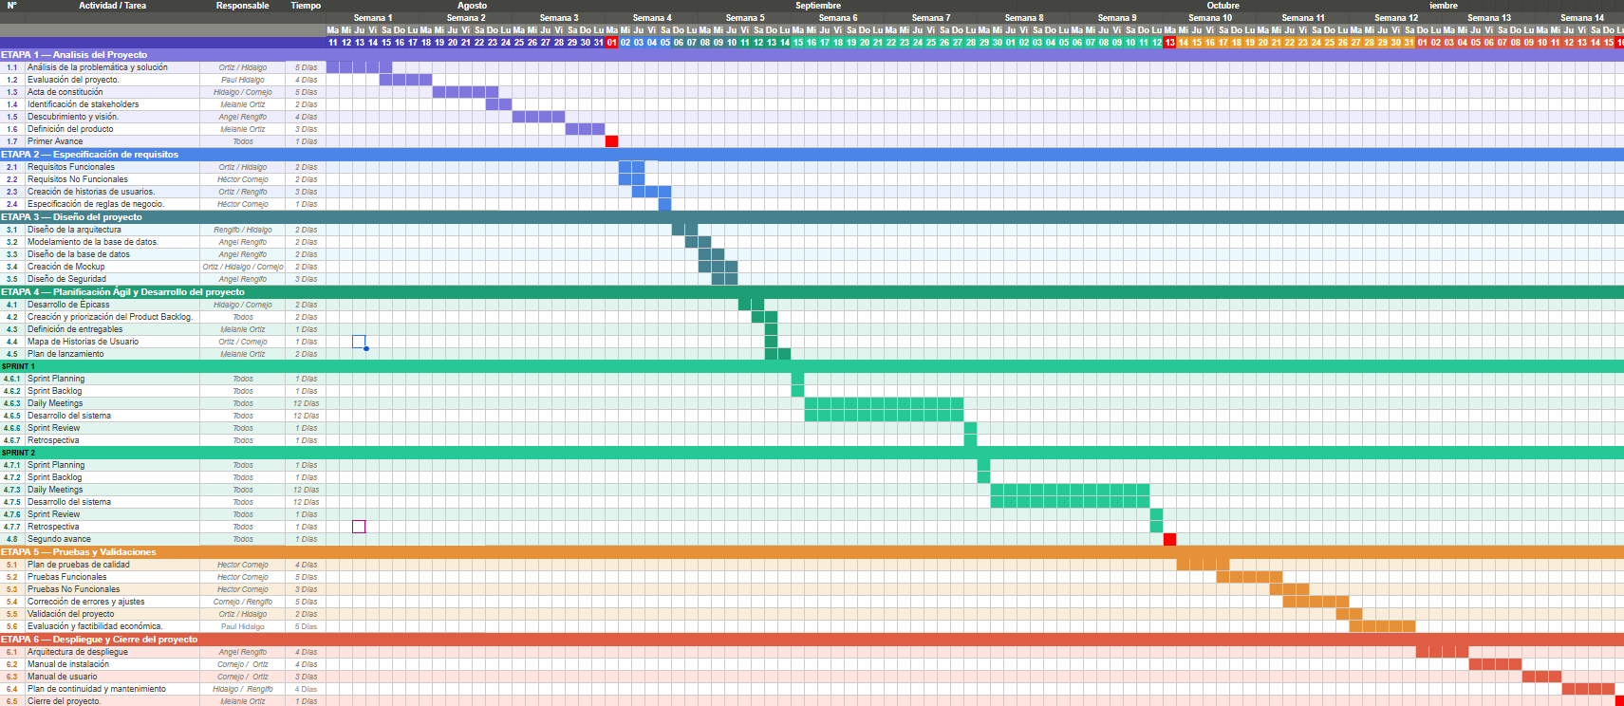
Archivo adjunto: CartaGantt.xlsx

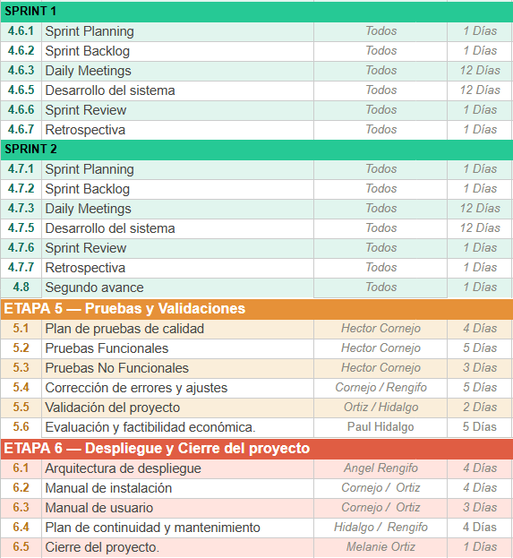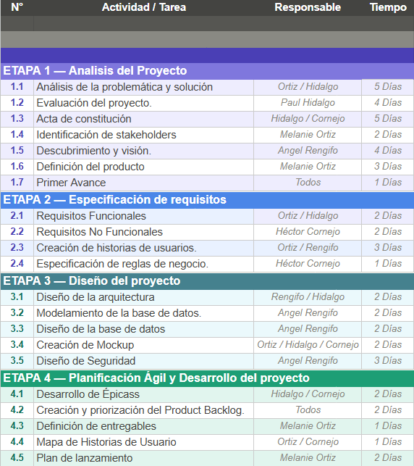

En caso de que el Proyecto APT sea grupal, en esta columna deben indicar el nombre de los responsables de cada tarea o actividad. Esto posteriormente permitirá diferenciar la evaluación por cada integrante.

